**Parameterisation of individual leaf approach for pearl millet and sorghum**

**Background**

For the simulation of canopy leaf area development, the released sorghum model uses the total plant leaf area (TPLA) approach. This approach has descriptive parameters that capture the shape of the leaf area development function, and relies on a user defined tiller number per plant. The TPLA approach is essentially an integration of the individual leaf area (ILA) approach. In order to make simulation of canopy leaf area development more dynamic, we are developing a dynamic tillering module that captures tillering as a function of an internal carbon supply/demand balance, and an intrinsic genotypic propensity to tiller. Implementation of this dynamic tillering module, however, requires the implementation of an ILA approach

Availability of a dynamic tillering module is important for pearl millet, which is a summer C4 crop like sorghum, but is much higher tillering. The pearl millet model is currently being incorporated into the sorghum/maize modelling platform. The released pearl millet model had already an ILA approach implemented, although this was done in a rather cumbersome manner, with different parameterisations for the main shoot and each of five tillers (van Oosterom et al., 2001). The implementation of the pearl millet model in the sorghum/maize framework, combined with the development of a dynamic tillering module, requires the development of an ILA approach that can be implemented across sorghum, pearl millet, and maize.

**Approach for implementing the ILA framework**

The ILA approach consists of a bell-shaped function that calculates the area of individual leaves as a function of the Total Leaf Number (TLN) of an axis (Dwyer and Stewart, 1986):

Y=Y0exp(a(X-X0)2+b(X-X0)3) (1)

where *X0* = position of largest leaf, *Y0* = mature area of largest leaf, *a* = empirical constant determining the breadth of the bell-shaped curve, *b* = empirical constant determining the skewness of the bell-shaped curve. More negative values for *a* result in a sharper peak of the function. Negative values for *b* result in the curve being skewed towards the left and positive values result in the curve being skewed towards the right. Reduced skewness is generally associated with a broader peak of the curve. Each of the parameters *X0*, *Y0*, *a*, and *b* is a function of TLN. The ILA approach has been parameterised for sorghum (Carberry et al., 1993), maize (Keating and Wafula, 1992; Birch et al., 1998), and pearl millet (van Oosterom et al., 2001). Although parameter values differ across crops, van Oosterom et al. (2001) commented that estimates for *X0*, *a*, and *b* are reasonably similar, suggesting that species differences in leaf area profiles may be predominantly associated with differences in *Y0*. In addition, results for pearl millet indicated that parameter values do differ between main shoots and tillers (van Oosterom et al., 2001), but these authors did not explore the possibility to derive tiller parameters form those of the main shoot.

In order to parameterise the ILA approach, we used the published parameters for sorghum, maize, and pearl millet as a baseline and added the following refinements:

1. Assuming that the relationships of *X0*, *a*, and *b* with TLN are not genotype dependent, determine parameters for these relationships that are common across crops.
2. Develop species and genotype specific parameters for the relationship between *Y0* and TLN
3. Determine if the bell-shaped functions give sensible results at very low and high TLN, outside the range of TLN for which the functions were developed. This is important for applications in photoperiod sensitive germplasm in Africa.
4. Develop algorithms to capture leaf area profiles of tillers using main shoot parameters.

This document will provide details on the comparison of parameter values across the three crops, and on the parameterisation of the above refinements. The purpose is, where possible, to develop parameters that are common across crops. Parameterisation will then be validated using simulations of leaf area profiles. Because of limited data availability for maize, the focus in this report will be on sorghum and pearl millet. Figures in this document are based on data collected from field experiments at ICRISAT (India) for pearl millet, and from field experiments and lysimeters experiments at Gatton for sorghum. The pearl millet data are the same as used in the ILA publication, whereas the sorghum data are different.

**Parameterisation of the relationship of *X0*, *a*, and *b* with TLN, common for pearl millet and sorghum**

Relationship of *X0* with TLN

For pearl millet, van Oosterom et al. (2001) reported only minor genotypic differences in the relationship between *X0* and TLN. For sorghum, Carberry et al. (1993) did observe significant differences in the slope of the relationship across seven genotypes. However, for five of these, the difference was non significant, whereas for the other two, the high and low slope were associated with a low and high intercept respectively. As these relationships included both main shoots and tillers, it is possible that genotypic differences in tillering may have caused these differences. As pointed for pearl millet, the slope of the relationship across all axes (main shoots and tillers) is considerably greater than the slopes for the relationships for individual axes (van Oosterom et al., 2001). Birch et al. (1998) also reported no genotypic effect on the relationship between *X0* and TLN. Hence, we assume that the relationship between *X0* and TLN is independent of genotype.

The next step in the parameterisation process is to determine whether common parameters can be used across crops, and if so, which ones to use. For all three crops, a linear relationship between *X0* and TLN was reported. For sorghum, Carberry et al., (1993, Table 2) only reported a relationship calculated across all axes (main shoots and tiller). As pointed out by van Oosterom et al. (2001), this is likely to overestimate the slope of the relationship. Indeed, the overall slope reported for sorghum (0.782; Carberry et al., 1993) is considerable greater than the slope reported for main shoots of pearl millet (0.60; van Oosterom et al., 2001, Table 3). Clearly, the published parameters for sorghum cannot be used to parameterise the main shoot. An analysis of the position of the longest leaf (which is generally similar to the largest leaf) as a function of TLN (Fig. 1) shows that the relationship between the position of the longest leaf and TLN is quite similar for sorghum and pearl millet. Therefore, the relationship published for main shoots of pearl millet (van Oosterom et al., 2001) should be valid for both sorghum and pearl millet:

*X0* = 3.58 + 0.60* TLN (2)

The two panels in Fig. 1, based on partly overlapping data sets, do suggest that the relationship between *X0* and TLN may not be linear at high TLN. The apparent contradiction between the two panels for plants with TLN>20 is associated with low number of plants with such high leaf number that were included in the analysis, plus a slight difference in the method of calculating the position of the longest leaf. Hence, results for plants with high TLN are less reliable. This issue will be addressed in more detail in the section on ‘Capturing plants with high TLN’ below. Importantly though, the effect of TLN on *X0* is similar for pearl millet and sorghum.

For maize, Birch et al. (1998) reported that *X0* is always located 2/3 up the stem and they report that for maize, *X0* = 0.67* TLN. In the absence of an intercept but with similar slope to the sorghum/pearl millet equation, this equation results in a position of *X0* around two leaves below the sorghum/pearl millet equation. This is consistent with our own preliminary results on the location of the longest leaf (Fig. 1). Hence, the effect of TLN on *X0* is different for maize as compared to sorghum and pearl millet.

In conclusion, the relationships to be implemented in the model are:

Sorghum and pearl millet: *X0* = 3.58 + 0.60*TLN (2)

Maize: *X0* = 0.00 + 0.67*TLN (3)

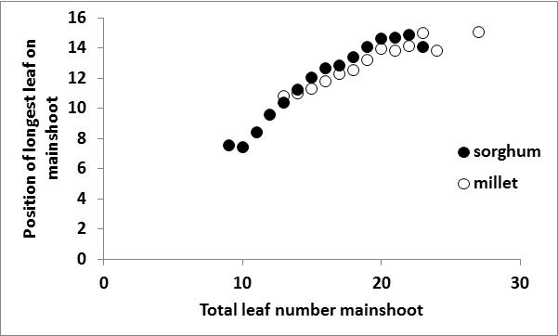 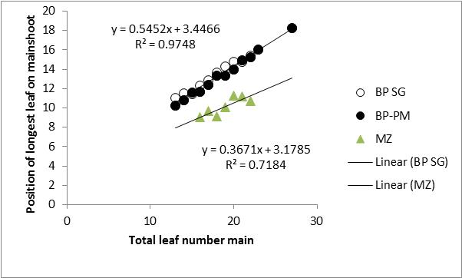

Fig. 1. Effect of total leaf number on the main shoot on the position of the largest leaf for sorghum, pearl millet, and maize. Data are means across plants. Two panels involve partly different data sets. van Oosterom, unpublished data.

Relationship of *a* and *b* with TLN

For the dependency of *a* and *b* on TLN, parameters that are specific to the main shoot have been published for sorghum (Carberry et al., 1993), pearl millet (van Oosterom et al., 2001), and maize (Keating and Wafula, 1992; Birch et al., 1998). For sorghum, no information on genotypic differences in parameter values for either a or b were provided, possibly because the number of plants was relatively small and the regressions with TLN not as tight as for *X0*. For pearl millet, genotypic effects were reported to be small. For maize, Birch et al. (1998) also used a common relationship between a and TLN and *b* and TLN, with reported genotypic differences in actual a and b used (Table 2) seemingly a consequence of differences in TLN (Fig. 2). Hence, the assumption here is that parameter values for the dependency of *a* and *b* on TLN are independent of genotype.

For the parameterisation of *a* and *b*, linear equations were used for sorghum, but asymptotic ones for maize and pearl millet, with similar type equations for both parameters within each crop:

Sorghum: *a,b* = u + v*TLN (4)

Maize: *a,b* = u – exp(v*TLN) (5)

Pearl millet: *a,b* = u + (v/(1 - w*TLN)) (6)

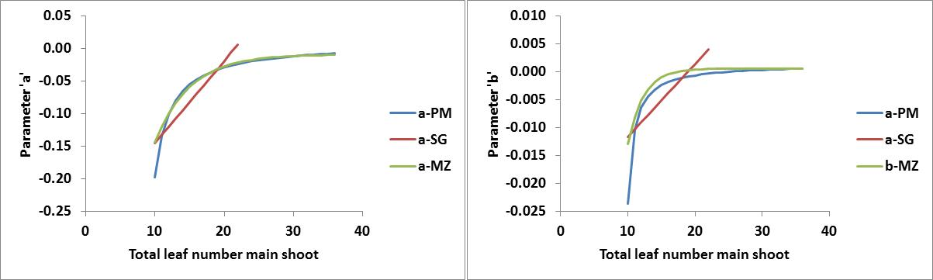

Fig 2. Values of parameters a (left panel) and b (right panel) as a function of total leaf number on the main shoot using published parameters for sorghum (dashed line; Carberry et al., 1993), maize (dotted line, Birch et al., 1998), and pearl millet (van Oosterom et al., 2001).

Within the observed range of TLN for the main shoot, the parameter estimates for pearl millet and maize are quite similar, in particular for *a* (Fig. 2). The main difference is at TLN=10, where the millet parameters are much lower than the maize ones. At TLN=9, values for parameter values for pearl millet become non-sensible. As expected, values for sorghum are quite different, because the parameter estimates are not asymptotic with TLN.

In order to assess the effects of the different parameterisation on the shape of the bell-function, values for *a* and *b* were estimated for different TLN, and combined with the *X0* parameterisation for sorghum and pearl millet (Eq. 2). Within species, parameters for pearl millet and maize provided sensible bell-shaped function across a wide range of TLN, except at low TLN. A comment made by van Oosterom et al. (2001) indicates that at high TLN, the pearl millet parameterisation becomes non sensible once TLN=35. For maize, ILA became non-sensible for L1-5 if TLN=9, whereas pearl millet became non-sensible for L1-5 if TLN 1as 10 or below (Fig. 3). Sorghum gave sensible bell shaped functions even at TLN=9, but estimates for upper leaves became non-sensible from TLN=20 onwards.

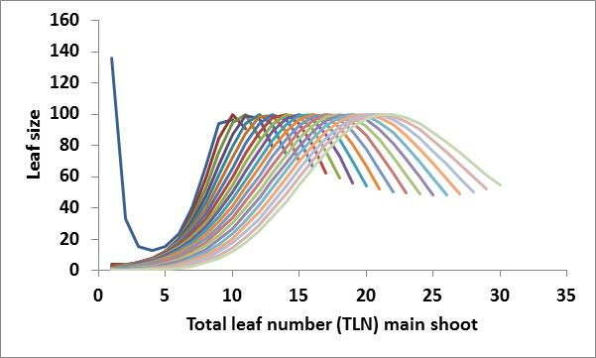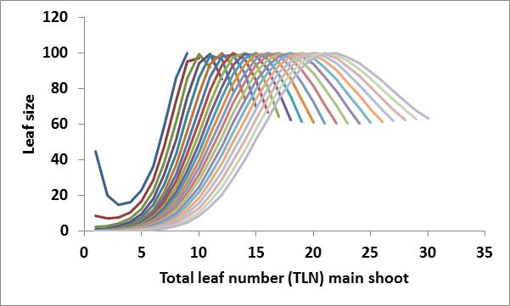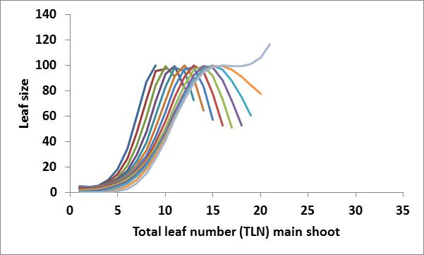

Fig 3. Leaf area curves using parameter estimates for *a* and *b* as a function of TLN (Fig. 2) for pearl millet (left; TLN=10-30), maize (middle; TLN=9-30) and sorghum (right; TLN=9-21).

A comparison of the equation for specific TLN showed that the parameterisations for the three crops resulted in similar leaf size profiles if TLN=11 (Fig.4). At higher TLN, leaf area profiles of maize were similar to those of sorghum below *X0*, and similar to pearl millet above *X0*, as illustrated for TLN=16 in Fig. 4. At higher TLN, the leaf area profiles for pearl millet and maize tend to converge. The main difference between the pearl millet and maize parameterisation is thus the difference in predicted size of lower leaves. Because the dynamic tillering model uses main shoot leaf area around tillering, some level of accuracy in the estimation of ILA of these lower leaves is required.

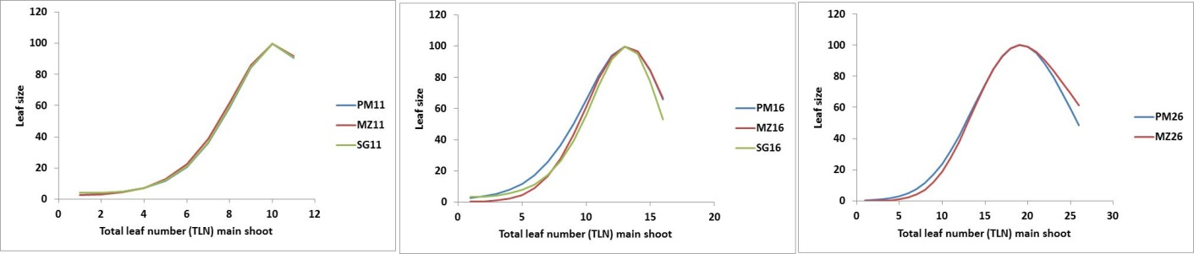

Fig 4. Comparison of leaf area curves form Fig. 3 across species for a common TLN: TLN=11 (left), TLN=16 (middle), and TLN=26 (right).

In order to determine which of the parameterisations best captures observed data, the predicted bell-shaped functions for each crop (Fig. 3) were compared with actual observations. The average size of each leaf was for all main shoots with a given TLN. For pearl millet, only plants for densities of 2 and 4 plants/m2 were used, whereas for sorghum and maize, all available data were used. For each TLN, the maximum observed average ILA was used as *Y0*. Results (Table 1) showed that for observed pearl millet data, the RMSD was generally lowest when the pearl millet parameters for *a* and *b* were used, whereas sorghum parameters gave the highest RMSD. For sorghum data, pear millet parameters were generally the best at higher TLN (17 and above) whereas sorghum parameters generally did best at lower TLN. For maize data, both pearl millet and maize parameters were overall comparable, whereas sorghum parameters generally gave the worst results (Table 1). Results in Fig. 5 for TLN=17 show that the pearl millet parameters generally best captured the size of the lower leaves of pearl millet and sorghum, whereas the maize parameters generally captured the maize leaf area profile better.

In conclusion, the results suggest that published parameterisation for *a* and *b* of pearl millet (van Oosterom et al., 2001) best captures the leaf area profiles of sorghum and pearl millet, whereas the published parameterisation for *a* and *b* of maize best captured the observed maize data (although the pearl millet parameterisation could also be used).

Sorghum and pearl millet

*a* = 0.00955 + (0.0608/(1 – 0.1293*TLN)) (7)

*b* = 0.00144 + (0.0025/(1 – 0.1100*TLN)) (8)

Maize

*a* = -0.009 – exp(-0.20*TLN) (9)

*b* = 0.0006 – exp(-0.43*TLN) (10)

Table 1. RMSD of observed vs predicted ILA for TLN ranging between 9 and 27 leaves. For predicted ILA, published crop-specific estimates for *a* and *b* were used (Eqs 4-6), whereas for *X0*, the equation used (Eqs 2 and 3) matched that of the observed species.

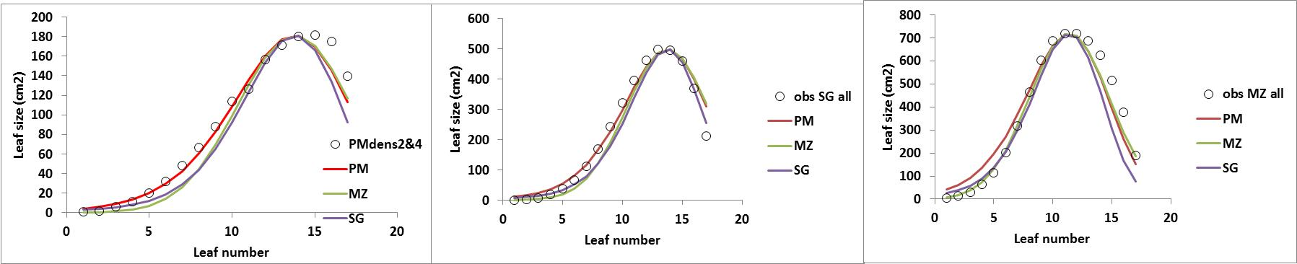

Fig 5. Observed average leaf size of main shoots with 17 leaves for pearl millet (left), sorghum (middle) and maize (right) and estimated leaf size using parameter values for a and b form published data for pearl millet (PM red; van Oosterom et al., 2001), maize (MZ, green; Birch et al., 1998), and sorghum (SG, purple; Carberry et al., 1993). For *X0*, the equation used (Eqs 2 and 3) matched that of the observed species. For *Y0*, the observed area of the largest leaf was used.

**Parameterisation of species and genotype specific relationship of *Y0* with TLN.**

In general, *Y0* increases linearly with TLN, with *Y0* the parameter defining the bell-shaped curve that is most affected by genotype (Keating and Wafula, 1992; Carberry et al., 1993; Birch et al., 1998; van Oosterom et al., 2001). Although values for the relationships for the three crops have been published, these values are often related to old germplasm and do require some updating.

The effect of TLN on *Y0* will be different for different species, as maize tends to have larger leaves than sorghum, which in turn has larger leaves than pearl millet. Although genotypes within species are likely to differ in this relationship as well, care must be taken not to over parameterise for individual genotypes, as the number of observations required for such individual parameterisations can be large. Rather, it may be wise to develop parameters for a few ‘groups’ and then for new genotypes with limited data, map results onto the regressions of these groups to determine what group that genotype belongs to.

Pearl millet

For pearl millet, parameter values for the effect of TLN on *Y0* were reported for low density (<5 plants/m2) and high density (>5 plants/m2) for four genotypes (BJ104, HHB67, RCBIC911, WRajPop) by van Oosterom et al. (2001). Using data for all plants under low densities (26-28 per genotype), the relationships for individual genotypes were not that great, with R2 ranging from 0.04 (HHB67) and 0.23 (RCBIC911) to 0.47 (WRajPop) and 0.64 (BJ104). The main trends was that RCBIC911 tended to have larger leaves than the other three genotypes. In order to minimise scatter, original data were re-analysed, by calculating the average observed *Y0* for all plants with a given TLN, grown under low plant density (<5 plants/m2). Two groups were made: RCBIC911, and the other three genotypes combined. Although the data are not balanced (each data point for each TLN is the average of a different number of plants) the results show that pooling of data tends to provide reasonable relationships (Fig. 6). Compared to the originally published data (van Oosterom et al., 2001), regressions of Fig. 6 tend to result in greater *Y0* under high TLN. Note that in the pooled data for BJ104, HHB67, and WRajPop, the data point for TLN=27 has been excluded from the regression. This data point was based on only a single plant, but importantly, there is some evidence that *X0*, and hence *Y0*, reaches a plateau around TLN=26; see section below on ‘Capturing plants with high TLN’.

In conclusion, the following parameterisation for the effect of TLN on *Y0* is suggested:

Standard leaf size: *Y0* = -143.1 + 22.8*TLN (11)

Large leaf size: *Y0* = -54.6 + 19.7*TLN (12)

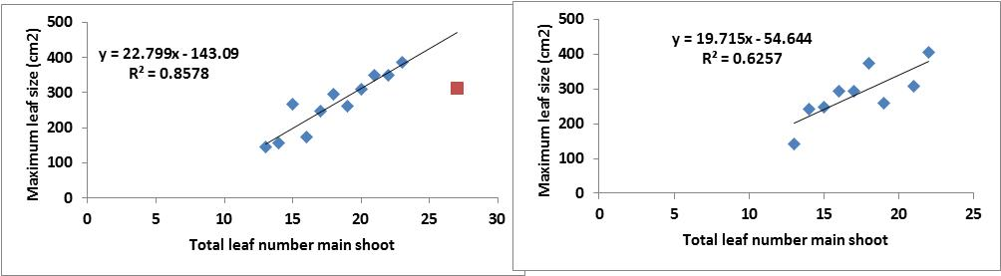 Fig 6. Observed maximum leaf size as a function of total leaf number on the main shoot for pearl millet plants of BJ104, HHB67, WRajPop (left panel) and RCBIC911 (right panel) grown at plant densities < 5 plants/m2. Data points are averages of all plants for a particular TLN. In the left panel, maximum leaf size of a single plant with 27 leaves was excluded from the regression, as there is some evidence that maximum leaf size reaches a plateau once TLN reaches a value of around 26 (see section below on ‘Capturing plants with high TLN’).

Sorghum

Data published for sorghum (Carberry et al., 1993) are all for old genotypes, so some information on modern germplasm is required. Most of the data collected for sorghum in Australia are for inbred lines grown as spaced plants in large lysimeters in a shadehouse. Some of the genotypes used are susceptible to Ca-deficiency under such artificial conditions; this can adversely affect the size of affected leaves and hence all subsequent leaves, even if the problem is only transient. Hence, care was taken to only include experiments and genotypes in the analyses where there was no obvious effect of Ca deficiency.

For most genotypes, the range in observed TLN is rather small. One exception is Buster, for which data from lysimeters and field experiments are available, with field experiments generally yielding higher TLN than lysimeter experiments. Calculating average *Y0* for all plants with a given TLN, gives the following relationship (Fig. 7):

Buster: *Y0* = -176.2 + 45.1*TLN (12)

This gives values for *Y0*, and hence for ILA, that are nearly double those of pearl millet standard leaves. This is consistent with data on leaf size that show that pearl millet and sorghum have similar leaf length, but that sorghum leaves are about twice as wide as those of pearl millet (van Oosterom, unpublished data).

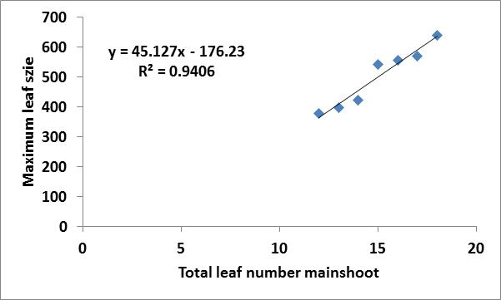

Fig 7. Observed maximum leaf size as a function of total leaf number on the main shoot for sorghum genotype Buster. Data are means across plants for each TLN. Data for three lowest TLN are from lysimetry experiments, data for four highest TLN are from (de)tillering experiment of Lafarge et al (1998), using only treatments at 2 and 4 plants/m2.

Data on near-isogenic lines for tillering (Kim et al., 2010) indicated that consistent genotypic differences in leaf size do exist. In order to get an estimate of the range in leaf size, data on *Y0*as a function of TLN were plotted for plants grown in lysimeters at Gatton in late 2011 (Fig. 8A). As expected, *Y0* generally increased with TLN, but there was also quite a scatter around a common regression line. When genotypes were arbitrarily classified into groups with large and normal *Y0*, the difference in *Y0* is around 20%. Interestingly, The regression for ‘normal leaf size), which included Buster, was quite close to the regression for Buster obtained in Fig 7 (Fig 8B). A range of about 20% in *Y0*is consistent with the range in leaf size observed for near isogenic lines by Kim et al. (2010).

In summary, the relationship between *Y0*and TLN obtained for Buster across lysimeter and field experiments was consistent with relationships obtained in a single lysimeter experiment across genotypes. Hence, Eq 12 could be used as a default setting for the effect of TLN on *Y0*, while low-tillering genotypes with large leaves may have *Y0* of upto 20% greater.

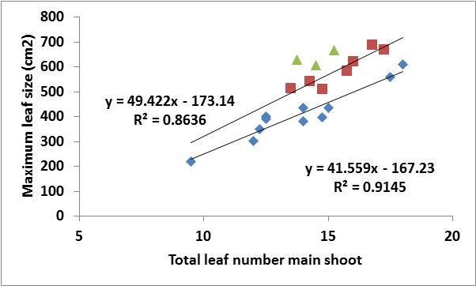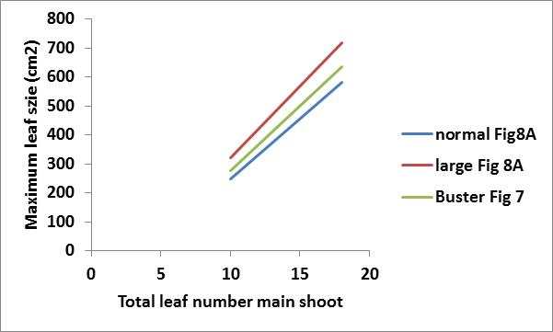

Fig. 8A. Observed maximum leaf size as a function of total leaf number on the main shoot for sorghum genotypes grown in large lysimeters at Gatton in late 2011. Each data point is the mean across 4 plants for a single genotypes. Genotypes have arbitrarily been grouped into those with large and small *Y0*.

Fig 8B. Comparison of regression lines of Fig 7 (Buster) with those of Fig 8A (normal and large leaf size).

+++++++++++++++++++++++++++++++++++++++++++++++++++++++++++++++++++++++++++++++

**Capturing plants with high TLN**

* If TLN>26, we just repeat Y0 as per discussions earlier this week.

**Develop algorithms to capture tillers using main shoot parameters**

* How many leaves to subtract? For millet, we have published data on TLN in T3, T4, T5 etc relative to the M. Alternatively, we can look at individual leaf size and see whether L1 of T3 is similar to which main shoot leaf? The first option (difference in TLN between M and T) seems the most straightforward?
* How do we estimate Y0 of a tiller relative to that of the main shoot. I looked into this for millet, and the correction factors are 0.95 (T3), 0.95 (T4), 0.90 (T5) and these relationships are pretty tight. For sorghum, there is much more scatter, but basically, maximum values for sorghum fit on the millet regression. So seems that potential for sorghum is same as millet, but often that potential is not reached (density effect?)

**Simulations/validation**

* Need to add some validations / simulations here.

**References**

Birch CJ, Hammer GL, Rickert KG. 1998. Improved methods for predicting individual leaf area and leaf senescence in maize (*Zea mays*). Aust. J. Agric. Res. 49: 249-262.

Carberry PS, Muchow RC, Hammer GL. 1993. Modelling genotypic and environmental control of leaf area dynamics in grain sorghum. II. Individual leaf level. Field Crops Res. 33: 311-328.

Dwyer LM, Stewart DW. 1986. Leaf area development in field-grown maize. Agronomy J. 78: 334-343.

Hammer GL, Carberry PS. Muchow RC, 1993. Modelling genotypic and environmental control of leaf area dynamics in grain sorghum. I. Whole plant level. Field Crops Res. 33, 293-310.

Keating BA, Wafula BM. 1992. Modelling the fully expanded area of maize leaves. Field Crops Res. 29: 163-179.

Kim HK, Luquet D, van Oosterom E, Dingkuhn M, Hammer G. 2010. Regulation of tillering in sorghum: genotypic effects. Annals of Botany 106: 69-78

Lafarge TA, Broad IJ, Hammer GL. 2002. Tillering in grain sorghum over a wide range of population densities: Identification of a common hierarchy for tiller emergence, leaf area development and fertility. Annals of Botany 90, 87-98.

van Oosterom EJ, Carberry PS, O’Leary GJ. 2001. Simulating growth, development, and yield of tillering pearl millet. I. Leaf area profiles on main shoots and tillers. Field Crops Research 72: 51-66.

1. **Current status of the work: development within milletP framework (=sorghum model with additional functions including ILA, we don’t have anything better available for testing now).**

***Sorghum/Millet_leaf_area_devel***

*MilletP has the structure to choose from different algorithms for calculation of plant leaf area (set of parameters needed to run sorghum/millet are in documentation_millet_sorghum.xls):*

* ***TPLA approach (Birch et al 1998)*** *– needs following parameters:*
* *TPLAmax,*
* *TPLAinflection ratio,*
* *TPLAproduction cf,*

*Here the TPLAmax defines the maximum total plant leaf area:*

tplaMax = (pow(FTN + 1.0, tillerCoef) * pow(finalLeafNo,mainStemCoef)) * scm2smm;

TillerCoef = 0.66 (is considered constant); FTN- fertile tiller No,

We optimize the mainStemCoef

*TPLAinflection ratio, TPLAproduction cf define skewness and breath of the TPLAmax function (“early vigour” related parameters); then every day TPLA is calculated:*

TPLA = TPLAmax / (1 + exp(-tpla_prod_coef * (TTemerg_to_now - tpla_inflection)));

TPLA inflection = (TTemerg_to_flag * tpla_inflection_ratio)

*TTemerg_to_flag = Flowering time - 100 TT*

*Here we optimize* *c_tpla_inflection_ratio ; -p_tpla_prod_coef*

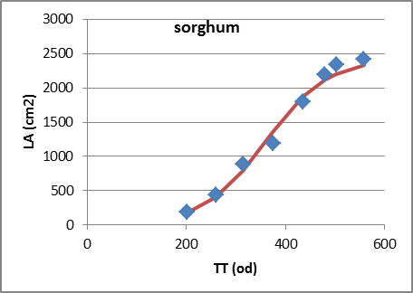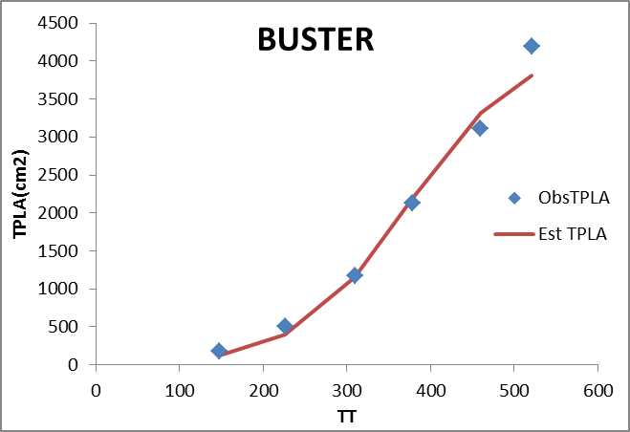

* ***ILA approach (Birch et al 1998)*** *is implemented in milletP currently and needs following parameters:*
* *MS Largest leaf multiplier (aX0),*
* *Largest Leaf Area Factor (aMaxSlope),*
* *Intercept for Largest leaf calculation (aMaxIntercept)*

this function has been used according to Lafarge&HaeKoo 2003, Carburry et al. 1993, Birch et al 1998 AJAR, vanOosterom 2001. However, we found that the function collapses (similarly as TPLA function, above) for large leaves Nos. and loses the predictive capacity for leaves profiles with LNo>26 leaves (African germplasm, long duration sudanian-zone adapted genotypes). Therefore, the algorithm is going to be implemented (data and ideas from M. Vaksmann - CIRAD).

1. *For leaves profiles with LNo max<=26 we implement the ILA approach with a&b constants from Birch et al 1998 approach:*

* Calculate relation between MaxLNo and LA of the largest leaf; LAmax=MaxLNo*aMaxSlope+aMaxIntercept

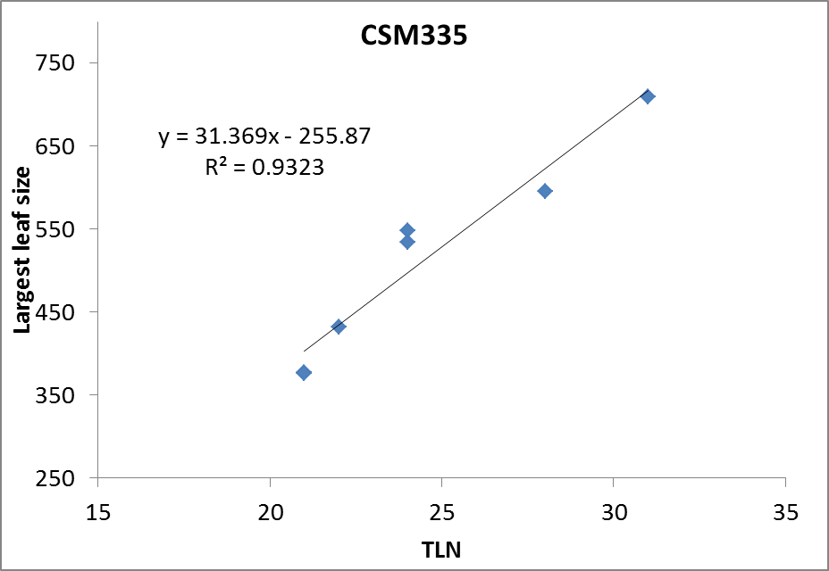

* Predicted Leaf size: leaf 1; LA(1)= (MaxLNo*aMaxSlope+aMaxIntercept)*exp(b*((1-x0)^2)+b*(1-x0)^3));

X0=aX0*MaxLNo;

a=a0-exp(a1*MaxLNo),

b=b0-exp(b1*MaxLNo),

empirical constants: a0=-0.009; a1=-0.2; b0=0.0006; b1=-0.43 (from Birch et al 1998)

I suggest we better optimize aX0 since things can go really wild – see below in section *c* (for now I see aX0 as a break-pedal, which may be needed at this stage – however, there is negative trade-off with having model with more generic functions?)

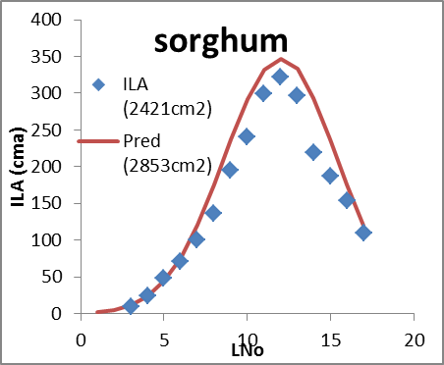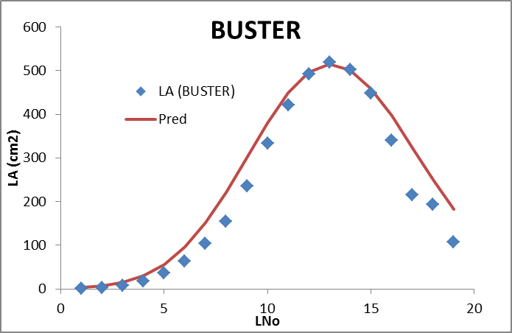

1. *For leaves profiles with LNo >26;*

|  |
| --- |
| condition1: IF largest Lno<20 for optimized aX0 THEN apply original algorithm; for  TLN>26 use a coefficient upto the largest leaf and from x0 use constant a=-0.018 - then the function won`t collapse anymore; ELSE plateau from the largest leaf No =20 add1)    1) optimize Birch's equation for the TLN when the position of largest leaf=20  2)see how many leaves are descending  3)repeat the largest leaf 20 - No of the repeats will depend on how many leaves will be descending in point 2); i.e. No of repeats in plateau=TLN-20-No of repeats from point 2) |
|  |
|  |
|  |
|  |

1. *generic ILA function (under development) = is there anything better and more generic than Birch?;*

As described above (part 1&2&3) we need to work towards more generic functions explaining well-enough the canopy growth dynamics – at the same time, we cannot trade-off on predictive value of the model. Therefore, various approaches to model ILA curve are being tested to see if we could get any more generic&similarly accurate canopy predictions.

**Test of equations – LNo sensitivity test:**

* Birch et al 1998 – the function works reasonably well upto 32 leaves – then goes wild

LA(1)= (MaxLNo*aMaxSlope+aMaxIntercept)*exp(b*((1-x0)^2)+b*(1-x0)^3));

X0=3.58+0.6*TLN (from EVO2001);

a=a0-exp(a1*MaxLNo),

b=b0-exp(b1*MaxLNo),

empirical constants: a0=-0.009; a1=-0.2; b0=0.0006; b1=-0.43 (originally for maize),

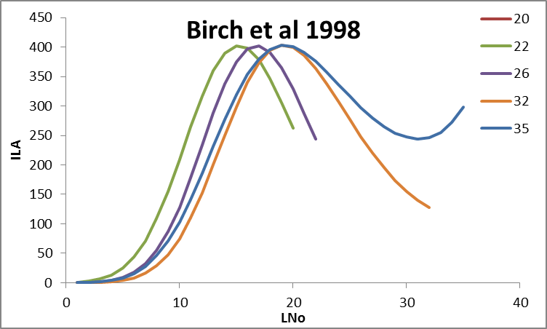

* Carberry et al 1993 – the function works really well for LNo below 20 but goes wild quickly after that

LA(1)= (MaxLNo*aMaxSlope+aMaxIntercept)*exp(b*((1-x0)^2)+b*(1-x0)^3));

X0=3.58+0.6*TLN (from EVO2001);

a= -0.271+0.0126*MaxLNo

b= -0.0246+0.0013*MaxLNo

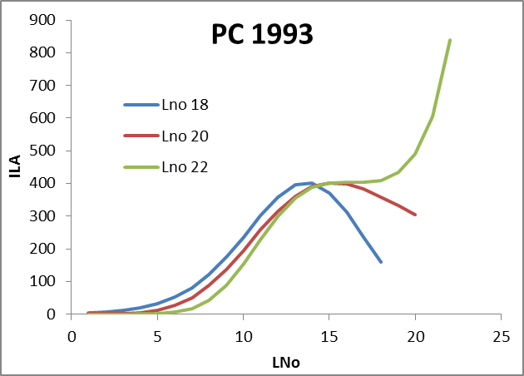

* vanOosterom et al 2001 – looks upto 30 leaves = can be the option used to improve the equations?

LA(1)= (MaxLNo*aMaxSlope+aMaxIntercept)*exp(b*((1-x0)^2)+b*(1-x0)^3));

X0=3.58+0.6*TLN;

a= -(0.00955+(0.0608/(1-0.1293*MaxLNo))

b= (0.00144+(0.0025/(1-0.11*MaxLNo)))

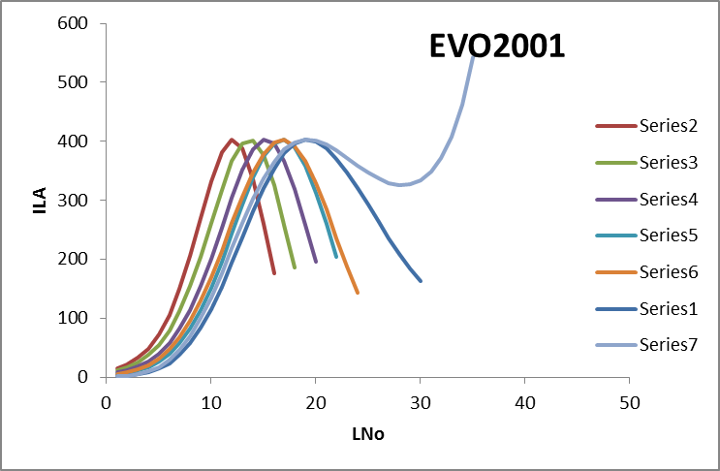

* Comparison of Birch, PC, EVO for LNo 20: - indeed, I can see the difference in the curve balance now. I will see what difference this can make for sims (below). The main problem is if we wont predict the largest leaf position properly – then we may get wrong the dynamics of canopy development – see the sim comparing the approaches at the end of doc. The question is if the observations are abnormal or if there is G effect on position of the largest leaf which matters (Buster is not the only case - many profiles won’t fit though predicted canopy size is not so bad?)

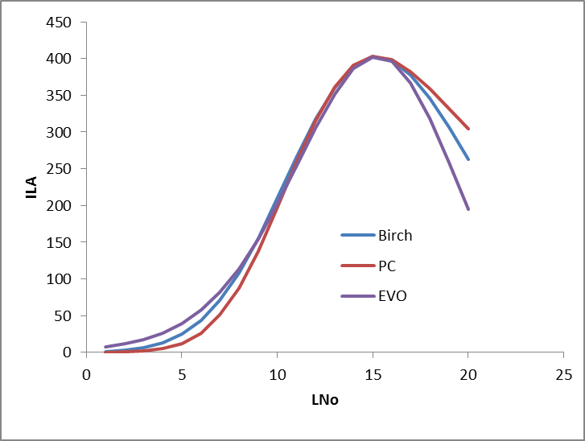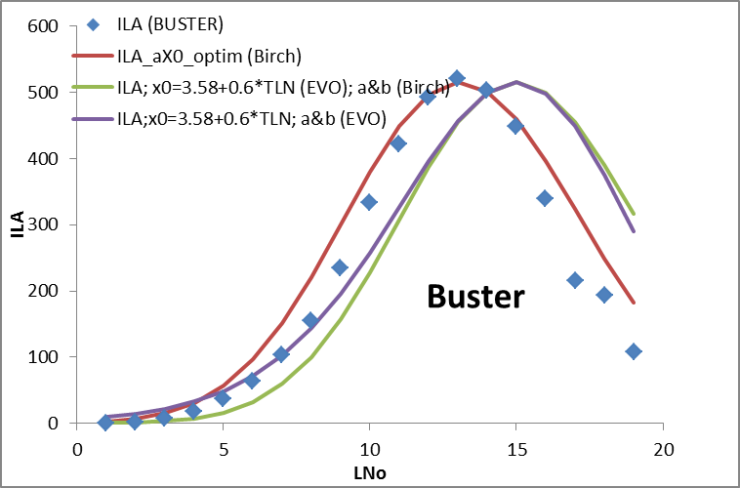

* Testing the relation TLN versus a & b coefficients (defining breath&skewness of the ILA-curve);

a&b optimized for equations using EVO2001 approach - relation is probably non-linear as described before (16 genotypes of sorghum&millet used – single point=genotype, I can add more if needed).

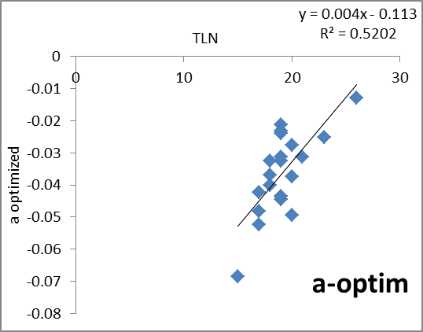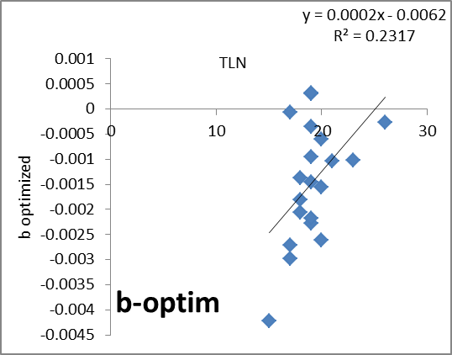

1. *Comparison of various approaches to predict MS-LA (TPLA, ILA, ILA_x0=3.58+0.6*TLN)*

Comparison of 1) TPLA versus 2) ILA (as described above) 3) ILA_ *x0=3.58+0.6*TLN* (under development described in part 3) predictive value on sorghum&millet example: each point is the average of genotype leaf profile (16 sorghum&4millet genotypes, 6 expts, India – Australia). Generally, TPLA approach seems to underestimate LAI while ILA approach overestimates it slightly. ILA_generic works reasonably well, but for certain sorghum types can go really wild (off-points is particular plant type of sorghum), my worries is that sometimes the total LA estimates are ok, but the predicted function is totally off (mainly due to inaccuracies in largest leaf position (x0=3.58+0.6*TLN) – this may result in under-over estimation of LAI growth dynamics in time but the question is that the difference of observed largest leaf position from predicted can be the result of some limitations in crop growth? Another issue is that any inaccuracies in MS estimation will cumulate for estimates of tillers LA.

Note: I can add more points if needed.

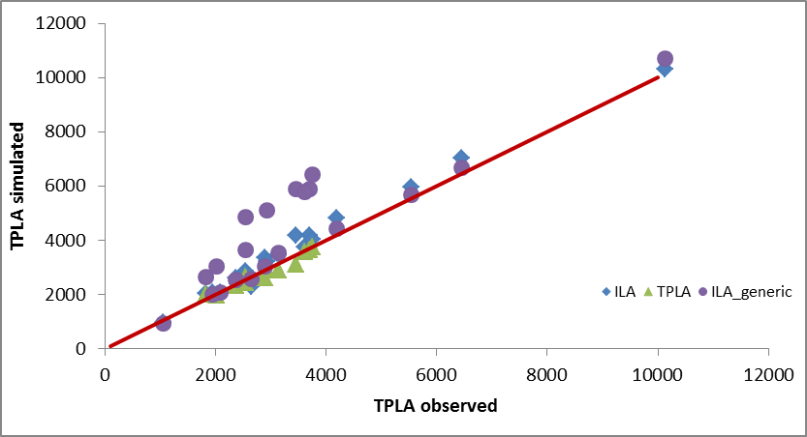

Comparison of simulations using 1) TPLA and 2) ILA_Birch function. Simulation of kharif grain sorghum genotype with no tillers – India (PVK).

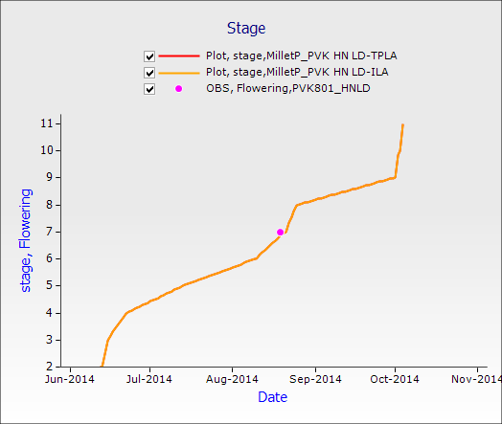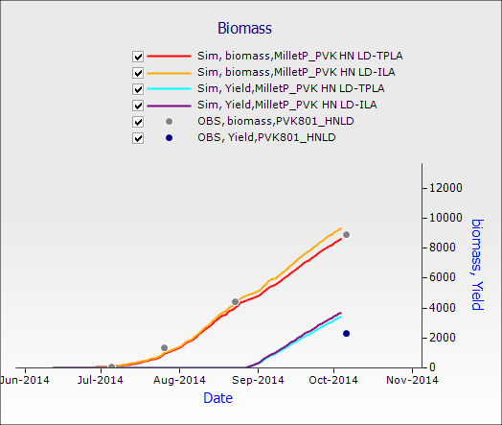

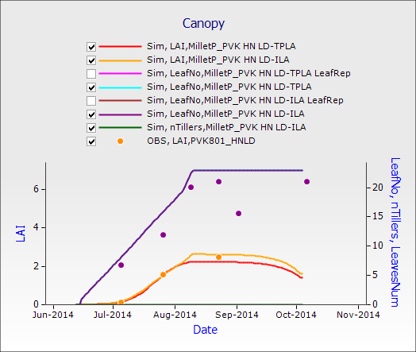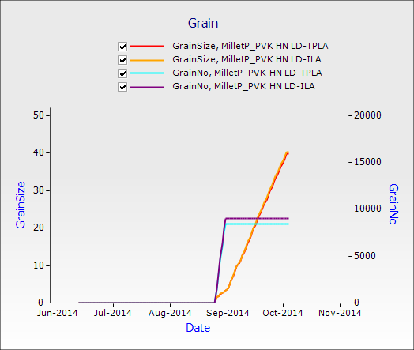

Comparison of simulations using 1) TPLA 2) ILA_Birch 3)ILA_a&b(Birch)_x0=3.58+0.6*TLN (EVO) functions. Simulation of MS-LA without tillers for sorghum genotype (BUSTER) – Australia.

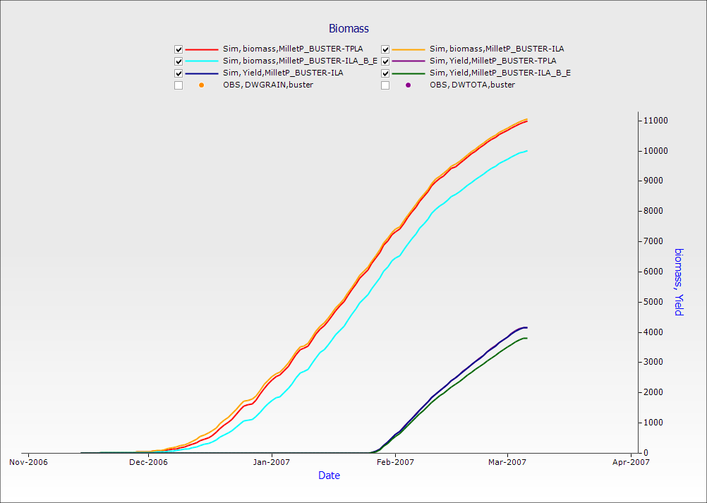 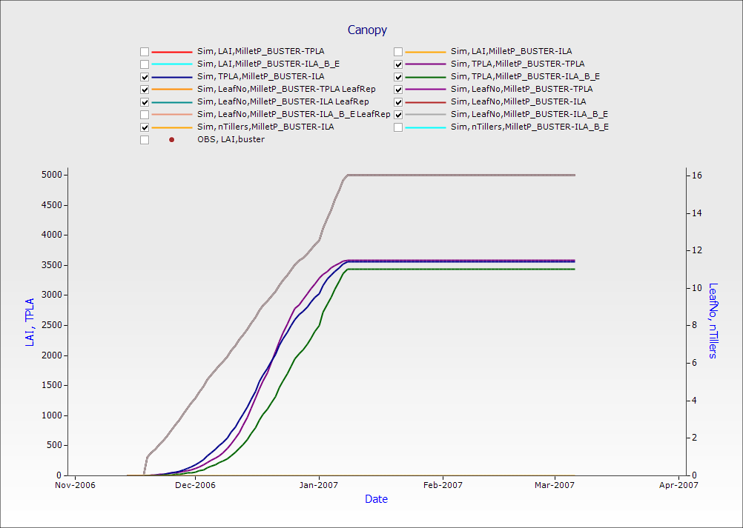

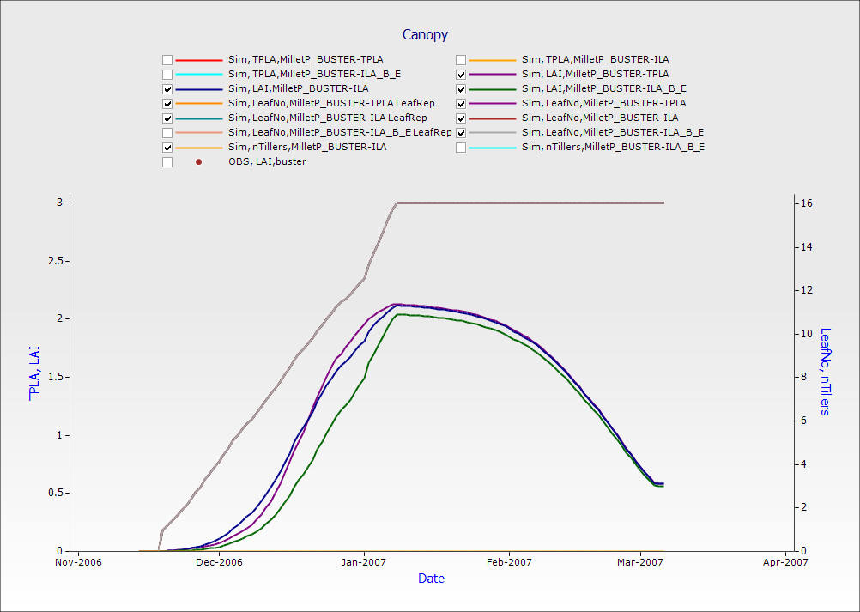 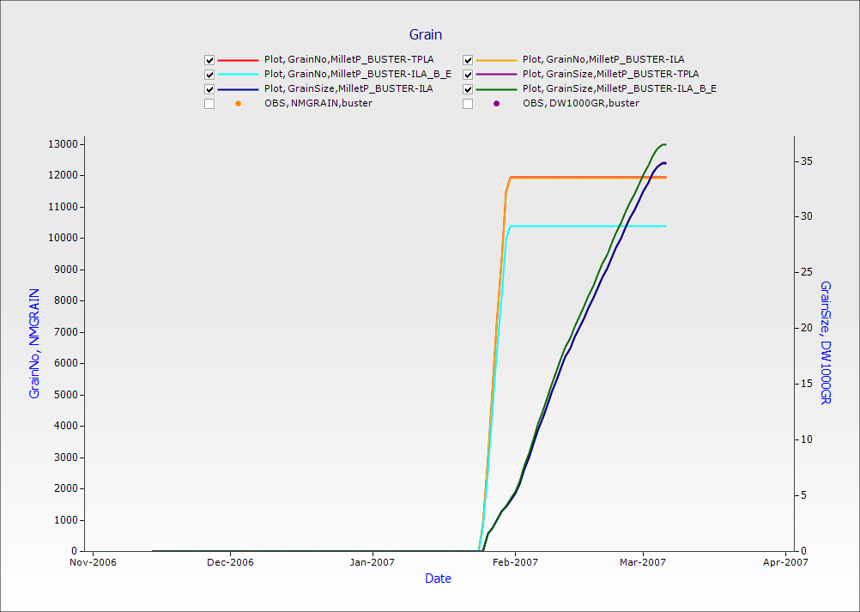

1. ***Bellcurve_with dynamic tillering*** *this approach needs following parameters:*

* *MS Largest leaf multiplier (aX0),*
* *Largest Leaf Area Factor (aMaxSlope),*
* *Intercept for Largest leaf calculation (aMaxIntercept),*
* *Propensity to tiller (P)*

ILA approach for characterizing the main stem is used (see above) as a basis for prediction of tiller leaves Nos & sizes. Tillers leaf area is calculated from these main stem ILA coefficients;

Tiller leaf No. & Tiller largest leaf size (this is coded and tested in millet P framework):

First tiller MaxLeafNo depends on the LNo of the MS – generally, T1 has as many leaf as MS-3; size of tiller leaf 1 and any consequent leaf size is calculated from the MS

T1LNo1=(T1LNo+3)*exp(a*((aMax(tiller)-x0)^2))+b*(((T1LNo+3)-x0)^3); a&b&x0 are the main stem coefficients (calculation above);

aMax(tiller)=0.7%aMax(MS-sorghum)

[aMax(tiller)=0.95%aMax(MS-millet) – since tillers of millet are larger]

and any following tiller has 5% smaller largestLA (just for the simplicity):

aMaxVert=0.05 -> decline 5% on all consequent tillers aMax;

Eric came with better numbers now:

Millet: T3 (95%), T4 (90%), T5 (90%)

Sorghum: T3 (85%), T4 (80%), T5 (70%)

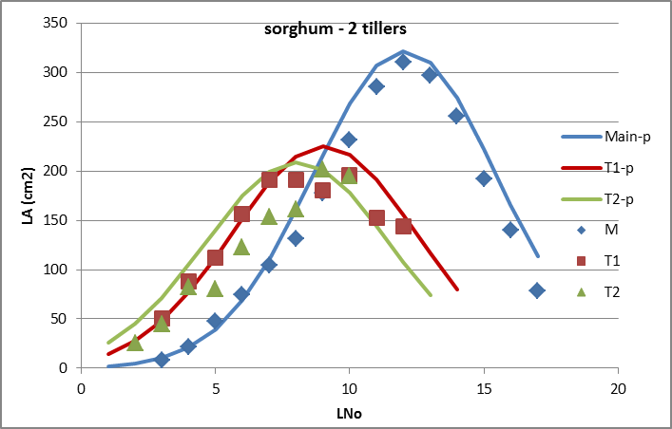 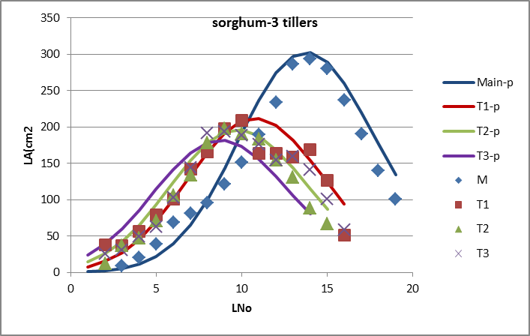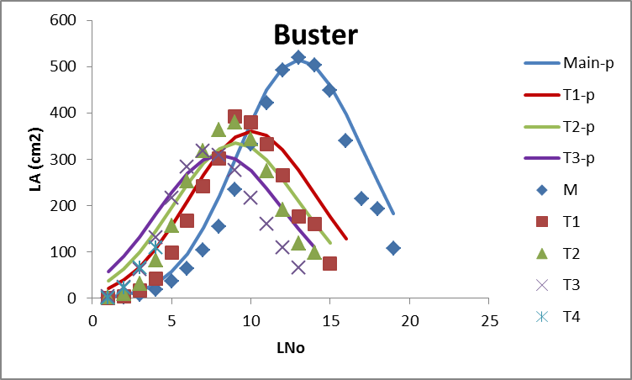

Tiller appearance (this is coded and tested within millet P framework)

Tillers generally start appearing from the base of leaf3 of the main stem (the time when L5 is under development) therefore model initiates tillering at **150dd** after crop emergence; the potential maximum tiller No is set at this time when LNo5 is developing (Hae Koo et al. 2001a,b);

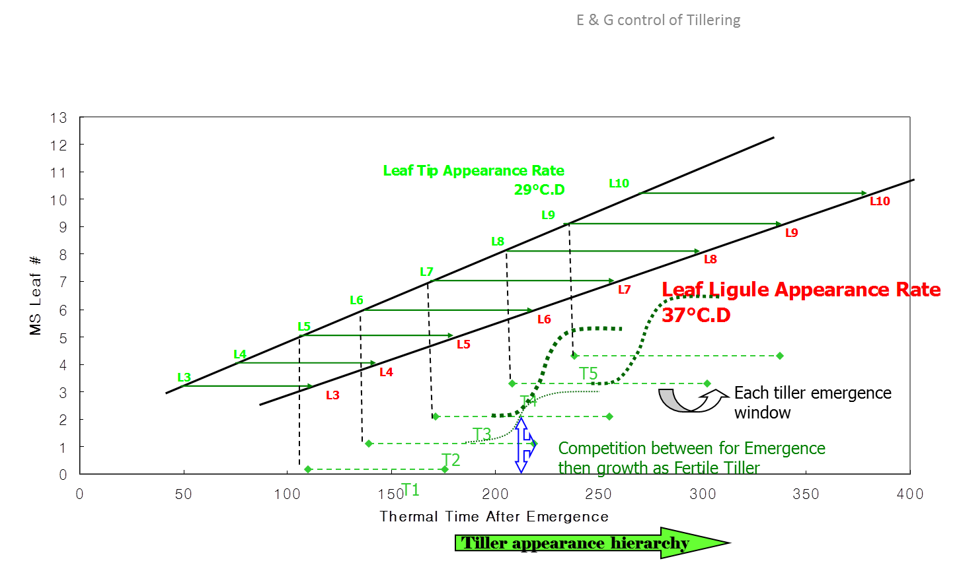

Tiller number (this NOT coded and tested within millet P framework – I am setting the tiller No manually for now)

The algorithm is based on the work of Hae-Koo et al 200x, Kim et al 2010a,b, Alam et al. 2014 with modifications. The basic principle builds on the estimation of carbon supply available for the MS leaf growth (~main carbohydrate demand) and the remaining carbohydrates could be allocated for tillers growth.

Potential Total Tiller Number is set at the stage when Leaf 5 is fully expanded:

TTN5 = P + C * S/D

TTN5 is Total Tiller Number calculated at Leaf 5 fully expanded

**P** is propensity to tiller is the intercept on the TNoMax vs S/D curve - Input

**C** is an intercept of linear regression between S/D and maximum tiller No - constant ~0.25 which fits all tillering types well (at least there is no evidence C differs) – however may need to be further validated

And **S** is supply calculated as R/oCd * LA5 * Phy5

* + - Where R/ oCd is average radiation per unit thermal time over the period of leaf 5 expansion (photo thermal quotient PTQ)
    - LA5 is the area of leaf 5
    - Phy5 is the phyllochron at leaf 5 (input from sorghum.xml or millet.xml - leaf_app_rate1 (41.0oCd for sorghum & 38dd for millet)

And **D** is demand calculated as DLA9-5

* + - Where DLA9-5 is the difference in leaf area (cm2) between leaf 9 and leaf 5.

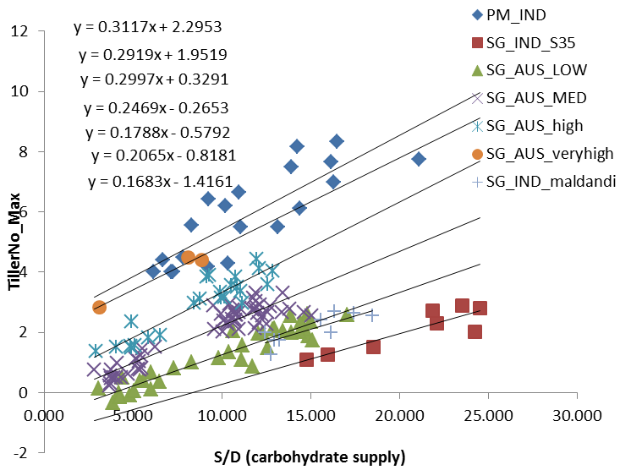

Tiller growth cessation (this NOT coded and tested within millet P framework – waiting to test it):

Tillers stop growing at LAI =0.65, or when there is no more carbohydrates supply for tiller leaf growth. Each day potential delta LAI is calculated. If there is not enough carbon supply available this day to produce estimated LA with the maximum allowed SLA (i.e. SLA<250 cm2/g), then the number of developing tillers will be reduced until today’s potential delta LAI gives us a SLA within bounds. I sense, this will be challenge!

Comparison of simulations using 1) TPLA and 2) ILA_Birch function. Simulation of MS-LA with 2 tillers sorghum genotype (BUSTER) – Australia (note: overestimations for ILA methos can be explained by overestimation of tiller size-since we don’t have sorghum tiller size difference implemented I used millet tiller size which is larger)

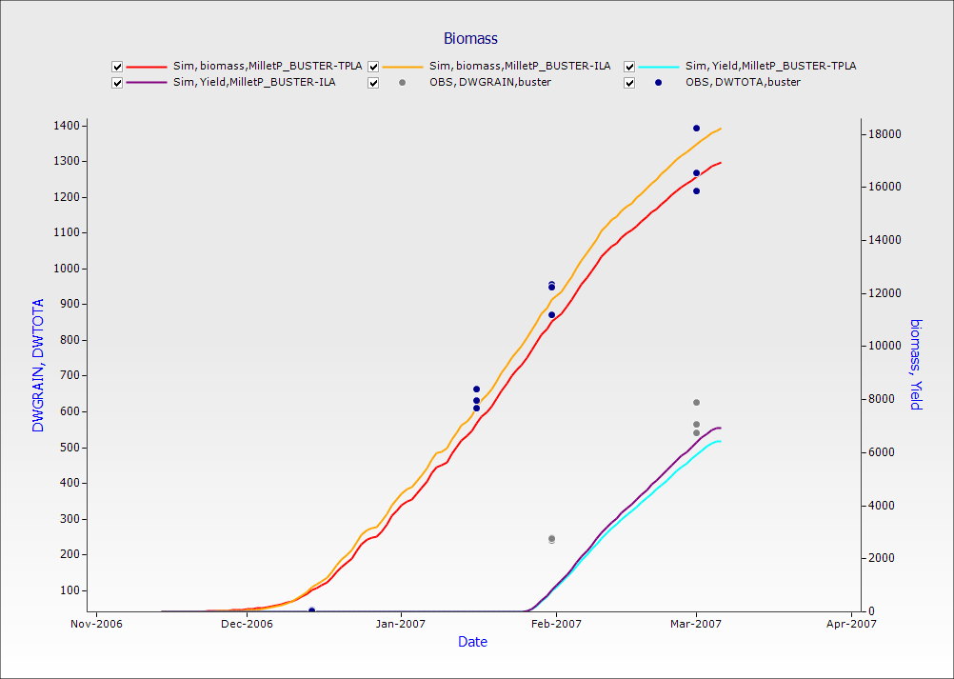 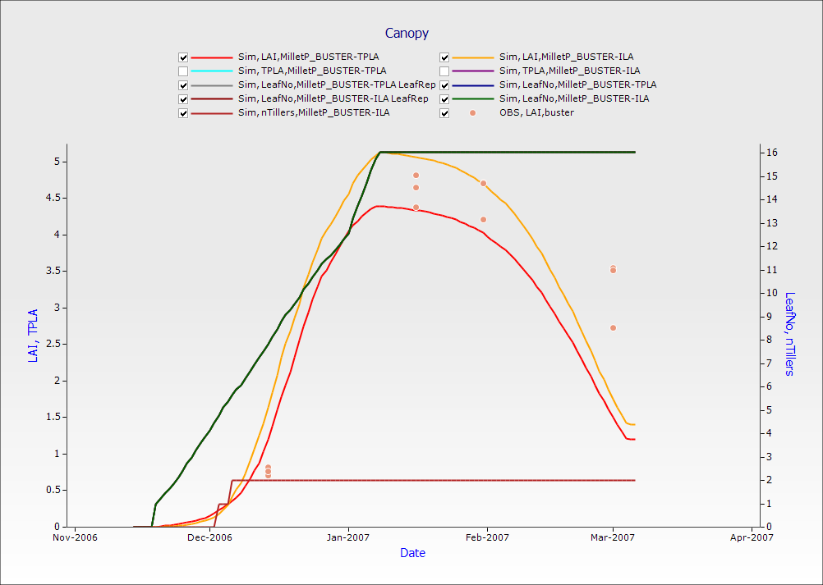

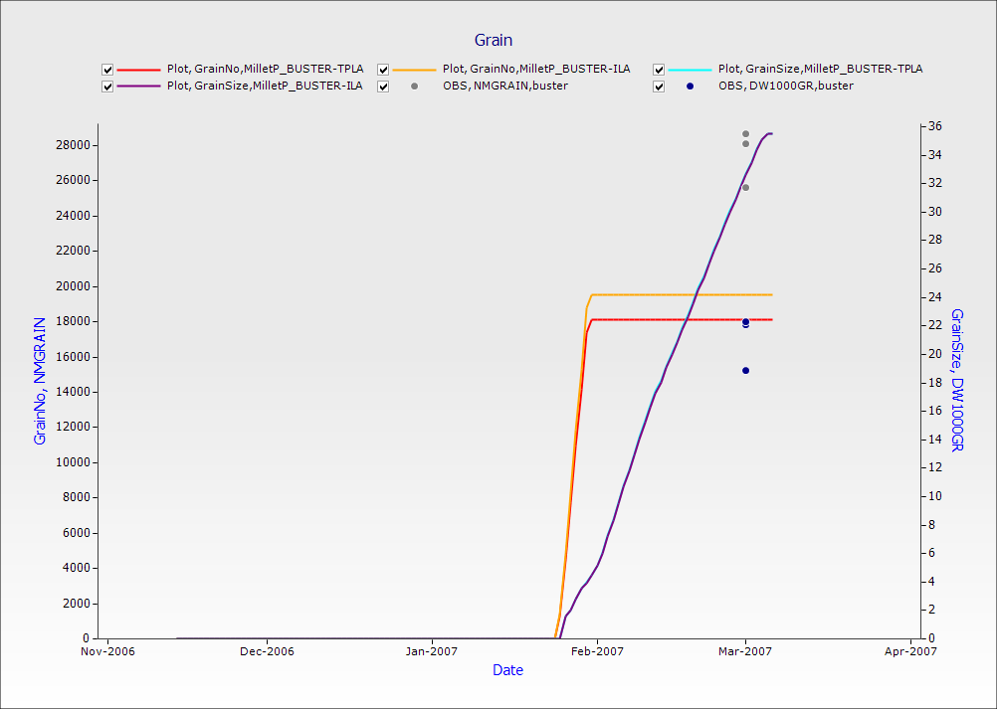 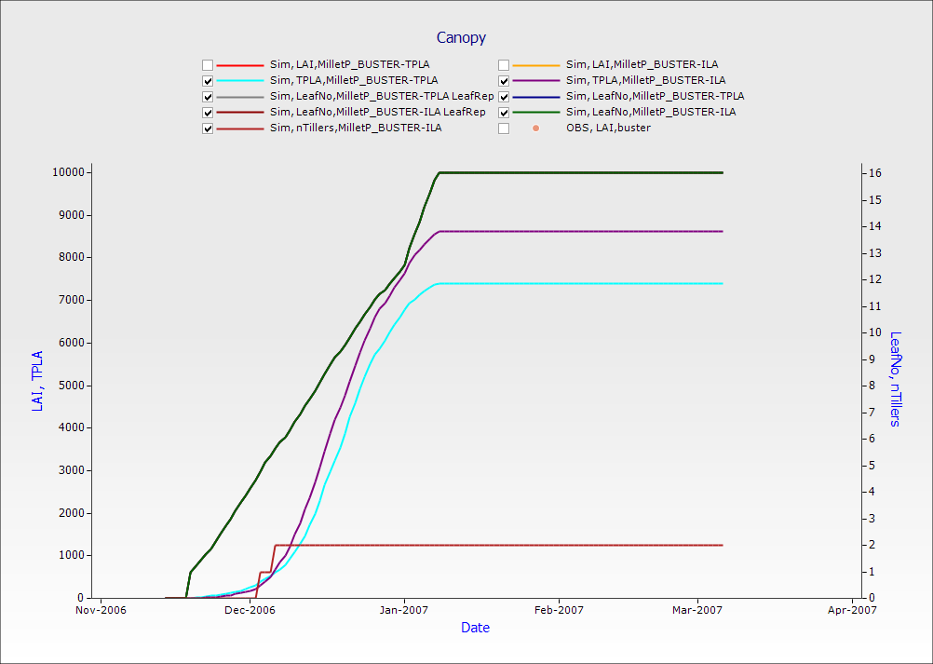

– will add sims on millet with tillers here

* Parameters for classes of different types of plants